**Evaluation of Deep Learning Models for Classification of Cervical Cancer**

**images journal**

A.Mohammed1 and K.Mohammed2, and A.Mishra3

aisha3236@bazeuniversity.edu.ng1 and khadijah.saad@bazeuniversity.edu.ng2, and amit.mishra@bazeuniversity.edu.ng3

1,2,3,4 Baze University, Abuja, Nigeria   
lncs@springer.com

**Abstract.** This paper uses deep learning for cervical cancer classification. For years, cervical cancer has been affecting women around the world and especially in third world countries due to absence of screening tools and misdiagnosis. This project is aimed at addressing the problem of misdiagnosis. Deep learning is a type of machine learning that is usually supervised and is widely used in the medical field. A deep learning model was created using Keras API. This project examines two types of Convolutional Neural Network (CNN) using transfer learning: MobileNet architecture and InceptionNetV3. The experiment achieved an accuracy of 67% on the dataset, so we recommend InceptionNetV3 Architecture for further development.

**Keywords:** Cervical Cancer, Deep Learning, Convolutional Neural Network.

1. **Introduction**

Cancer is a deadly disease in which some of the body’s cells grow uncontrollably (2018). These cells then spread to other regions of the body. When the body's natural control mechanism fails, it develops. It occurs anywhere in the body. In women, cervical cancer is the second most common cancer-related death. Cervical cancer occurs in the cervix of a woman which is the lowermost part of the uterus. It occurs most often in women above the age of 30. Cervical cancer affects women worldwide. It has a very high fatality rate due to the late presentation and diagnosis. Pap smear tests are the most common tests to detect cervical cancer. During a pap smear test, cells are taken from the cervix and properly checked for abnormality (2018). Long-lasting infection with Human Papillomavirus (HPV) is the main cause of cervical cancer (Basic Information About Cervical Cancer | CDC, n.d.). HPV is a common virus that is transmitted sexually. Symptoms of cervical cancer include: heavier periods than usual, blood spots or light bleeding between or following periods, bleeding after intercourse, pain during sexual intercourse, increased vaginal discharge, bleeding after menopause (Cervical Cancer - Symptoms and Signs, 2020). In Nigeria, cervical cancer occurs in 250 per 100,000 women (2018). There are 9992 cases diagnosed annually with 8030 deaths. It is said that The 5-year survival rate for all women with invasive cervical cancer is **66% (Cervical Cancer survival rate, n.d.)**. One of the preventive measures is the vaccination of pre-adolescents against oncogenic HPV. Deep learning is a subset of machine learning which is a neural network with multiple layers. This project will use Deep Learning to classify cervical cancer. This project addresses whether cervical cells are normal or abnormal. It also addresses issues of missed Cervical cancer. It passes Images of cells taken from Pap Smear into the neural network using deep learning.

# 

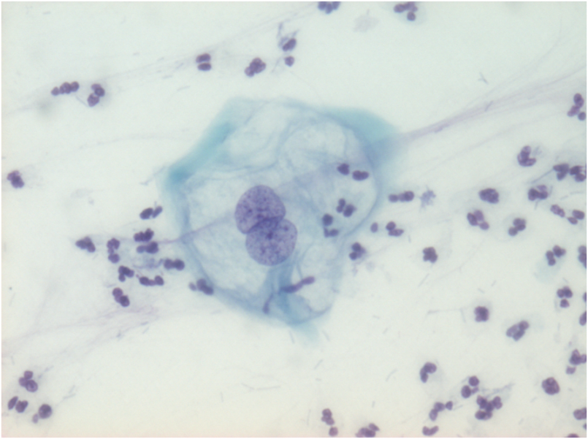

*Figure1.1*: *Atypical squamous cells of undetermined significance (ASC-US)*

Cervical cancer has a high rate of mortality in women. It has been estimated that every year14943 women are diagnosed with cervical cancer and 10403 die from the disease.So many cases still aren’t tested due to the absence of a reliable screening tool in rural areas. Previous studies have shown that cervical cancer occurs frequently in Nigeria due to late diagnosis and presentation at the advanced stages of the disease, which further leads to poor diagnosis.

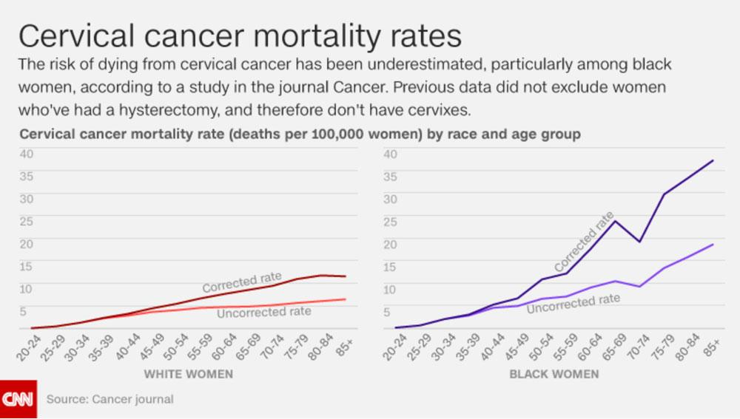

*Figure 1.2: Showing cervical cancer mortality rates.(CNN, 2017)*

## 

Cervical Cancer goes undiagnosed so many times due to many reasons. One is that abnormal cells sometimes look like normal cells. Even an experienced Histopathologist can miss the abnormality in the cells at times. This model will address the issue of missed diagnosis. This model is needed especially in Nigeria where the rate of Cervical Cancer deaths is more than that in a developed country.

1. **Related Works**

Deep learning has been used for years to classify images in the medical field. Earlier this year, Various convolutional neural network architectures were tested for the classification of cervical cell nuclei collected in Pap smears by a group of professors. They used MobileNet, XceptionNet, and InceptionNetV3 architectures to compare their performance with EfficientNets Architectures. The use of machine learning to differentiate between healthy tissue, pre-cancer, and cancer with 91 percent on a standard measure of the accuracy of machine learning predictions which is more successful than human visual inspection. The only Problem faced was getting enough data for the research (Dance, 2019). Convolutional neural networks were trained to detect similarities with pictures from brightfield and fluorescence microscopy of numerous cellular components, such as the mitochondria, cell membrane, and nuclear envelope. After comparing several pairs of images, the algorithm was able to predict the location of structures that fluorescent labels would have tagged, but in 3-D brightfield images of live cells. The performance was Very accurate and with only dozens of images. A model trained on images from one microscope may not operate on images acquired from another, which is a limitation of this technology (Kwon, 2019). Brief history of deep learning starting from Warren McCulloch and Walter Pitts invention of a computational model for neural networks in 1943 to a breakthrough of Artificial pattern-recognition algorithms that achieve and sometimes exceed human-level performance on certain tasks in 2012 (Marr, 2021). Scientists developed a distributed computing infrastructure for training large-scale neural networks. Then, using solely unlabeled Youtube footage, they trained models to learn what a cat looked like on its own (Dean and Ng, 2012). .Recent examples demonstrate how deep learning may be used to infer regulatory characteristics from DNA sequence in genomes. The use of DeepGestalt algorithms to identify patterns in patient face images and determine which of many probable genetic abnormalities is to blame for a person's illness. DeepGestalt was asked to determine which of five probable genetic abnormalities was underlying each instance in one experiment. Noonan syndrome is a condition that produces distinctive facial traits as well as birth and developmental issues. The algorithms had a success rate of 64 percent, which is greater than that of physicians (Offord, 2019). A brief history of AI, machine learning, artificial neural networks, and deep learning (Akst, 2019). The use of a neural network to predict lung cancer. it had a 94 percent accuracy. The model performed just as well as radiologists using more (data) images of the patient but didn't perform as well with just one image of the patient presented. Although, More testing is required before it is used clinically (Williams, 2019). Machine learning has the ability to transform healthcare for the better; especially the diagnosis of cancer but it can diagnose slow-growing, non-lethal cancers (Adamson, 2021). A deep neural network was created. Machine learning is used to differentiate among melanoma cells with high and low metastatic potential, meaning how probable the cancer is to spread (Makowski, 2019). HRMAn, a machine learning algorithm, was developed to analyse images of host cells and pathogens. They've used the software to look at infections caused by Toxoplasma gondii and Salmonella enterica in a number of human cell lines(Williams, 2019). The use of AI to detect covid19 using eye images. Coronavirus infections have long been linked to vision problems, yet only about 5% of patients really experience vision problems, so there isn't enough evidence. The model was quick and accurate, with a 90% accuracy rate. It will be effective in detecting covid19, but some privacy problems exist in various parts of the world because it will be used in public locations (surveillance cameras in airports etc) (King, 2020). Scientists trained so-called deep neural networks, computer models that learn nonlinear relationships between pairs of input data, to transform confocal and fluorescence microscopy images into high-quality pictures but it will fail because it doesn't preserve the differences (Akst, 2018). An Algorithm was trained by researchers to predict the race of patients in unlabeled images by feeding it images labeled with a patient's race. The algorithm worked well, with the lowest performing at 80%. However, racial bias is a major flaw with this software(Simonite, 2021).Researchers designed a neural network . They trained it by repeatedly presenting it with two sets of identical photos of the same cells, one without fluorescent labels and the other with fluorescent labels, until it could correctly predict fluorescent labels from an unlabeled image (Kerry Grens, 2018).

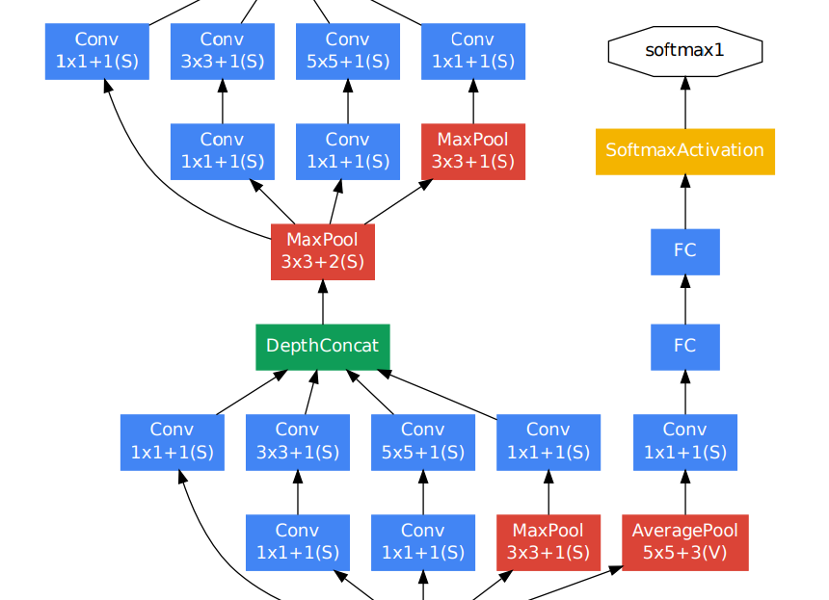

*Figure 2.2 InceptionNet Architecture (2018)*

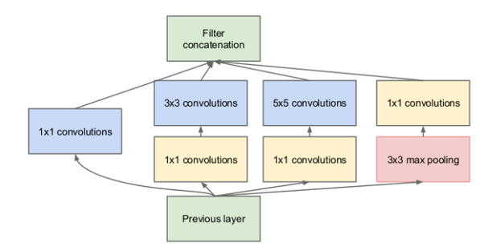

*Figure 2.3 GoogleNet Architecture(*Sharma, N., 2020*)*

1. **Materials and Methods**
   1. **Dataset**

This project required a large dataset that was going to be a challenge to find. After multiple meetings with the heads of the Pathology Department in multiple Nigerian Hospitals and centers, the search was broadened to the internet. The samples from Nigerian hospitals and test centers required ethical clearance that would delay this project, also, most of these test centers delete their data. Therefore, this research opted to use a dataset from the CRIC Searchable Image Dataset which includes cervical cell images developed by the Center for Recognition and Inspection of Cells (CRIC).

The images were generated by the Cytology Laboratory of the Pharmacy School in the Microscopy facility of the Biological Sciences Research Center (NUPEB) of the Federal University of Ouro Preto. The cell classification was done by three cytopathologists who examined the cells and grouped each to its corresponding class. The classes represent the cervical lesions: normal (i.e., negative for intraepithelial lesion or malignancy (NILM)); atypical squamous cells of undetermined significance (ASC-US); low-grade squamous intraepithelial lesion (LSIL); atypical squamous cells, cannot exclude high-grade lesion (ASC-H); high-grade squamous intraepithelial lesion (HSIL); squamous cell carcinoma (SCC).

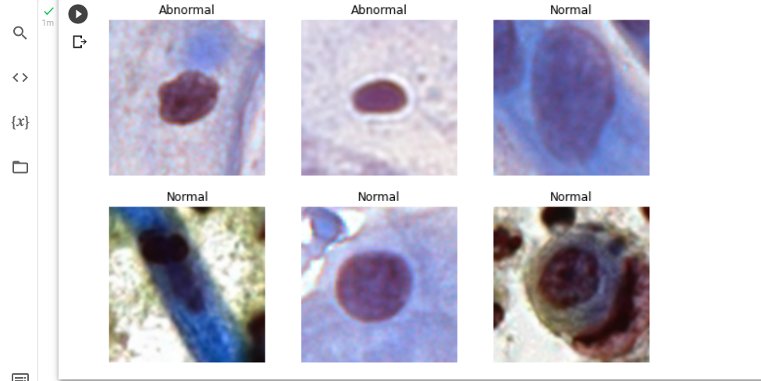

Fig. 3.1. Cervical cancer Images.

**Table 1.** Image Distribution.

|  |  |
| --- | --- |
| **Class** | **Total** |
| Normal (0) | 2757 |
| Abnormal (1) | 2756 |

* 1. **Data Splitting**

The images were split into training, validation, and test sets. 70% for training, 20% for validation, and 10% for testing. Validation gives information that can assist with adjusting our hyper-parameters. A test set is kept aside to compare final models.

* 1. **Data Augmentation**

Data Augmentation occurs when you create new data based on modifications of your existing data. By generating new and varied examples to train datasets, data augmentation can increase the performance and results of machine learning models. A machine learning model performs better and is more accurate when the dataset is large and enough. Data collection and labeling can be time-consuming and costly for machine learning models. Companies can lower these operational costs by transforming datasets using data augmentation techniques. In this project, the data is images and the transformations included Flipping and Rotating the image to obtain more data for training. Three transformations were performed; rotating the original image by 90, Flipping the image vertically and flipping the image horizontally.

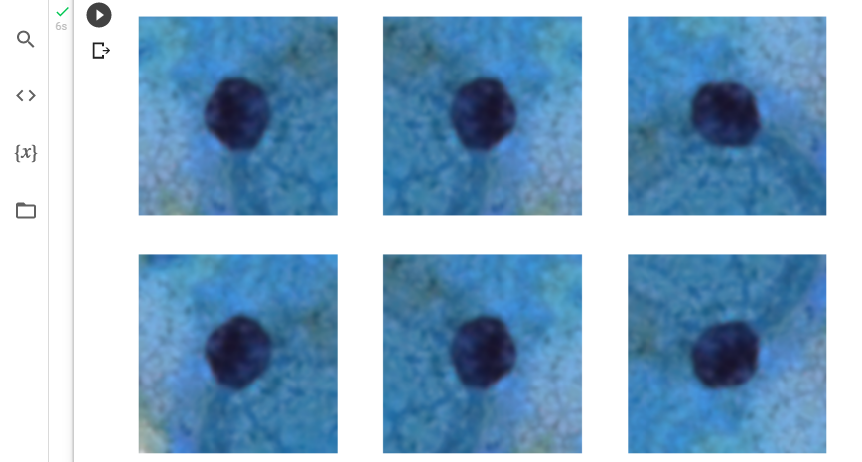

*Figure 3.2: Data Augmentation.*

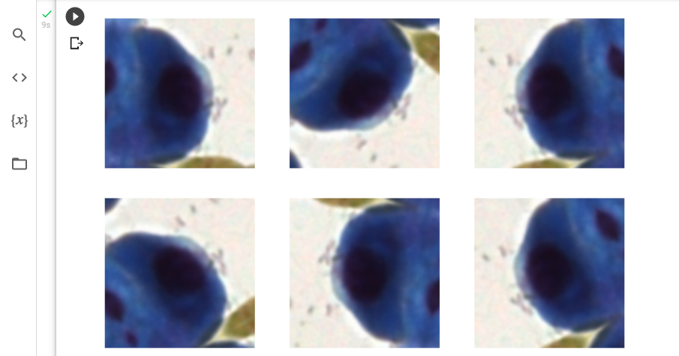

*Figure 3.3: Data Augmentation.*

* 1. **Model Training**

Using the keras API, A convolutional neural network with 7 layers was created and trained on the CRIC dataset. The model is a sequential model (having one input and one output) and a list of layers was passed to the sequential constructor to create it.

The [Sequential](https://www.tensorflow.org/guide/keras/sequential_model) model consists of convolution blocks ([tf.keras.layers.Conv2D](https://www.tensorflow.org/api_docs/python/tf/keras/layers/Conv2D)) with a max pooling layer ([tf.keras.layers.MaxPooling2D](https://www.tensorflow.org/api_docs/python/tf/keras/layers/MaxPool2D)) in each of them. One unit is placed on top of a fully  connected layer (tf.keras.layers.Dense) that is activated by a sigmoid activation function ("sigmoid").

Optimizer = ‘adam’ is the optimizer which is a method used to change the weights in a neural network so as to reduce the losses and improve the accuracy. Loss = ‘binary_crossentropy’ is the loss function which calculates the difference between the expected outcome and the machine learning model’s output. For each training epoch, we need to view training and validation accuracy , we pass the metrics argument to model.compile. An epoch is the number of passes over a dataset.

3.5 **Transfer Learning**

Taking a pre-trained model and retraining it for a new problem. It is very popular In image classification and natural language processing. Using transfer learning saves resources and computation power.

3.5.1 Transfer Learning with MobileNet

A MobileNet pre-trained model was used to classify the training dataset with adam optimizer and the learning rate as 0.001. After 5 epochs, the accuracy was 88%.

3.5.1 Transfer Learning with InceptionNetV3

A InceptionNetV3 pre-trained model was used to classify the training dataset with adam optimizer and the learning rate as 0.001. After 5 epochs, the accuracy was 90%.

1. **Results**

We experienced with pap smear image dataset. We used 70% for training and 20% for validation and 10% for testing. The accuracy obtained is summarized in Table 2. Total of 5 epochs were used for each model training. The models performed very well with the lowest being 88% and the highest accuracy being 90%.

* 1. **Confusion Matrix**

The confusion matrix for the transfer learning is presented in Fig. 5 and 6.

|  |  |
| --- | --- |
| TN = 185 | FP = 60 |
| FN = 16 | TP = 389 |

Fig 4.1. Confusion Matrix for MobileNet

|  |  |
| --- | --- |
| TN = 193 | FP = 50 |
| FN = 10 | TP = 397 |

Fig 4.2. Confusion Matrix for InceptionNetV3

* 1. **Accuracy, Sensitivity, and Specificity**

Accuracy = True Negative **/** True Positive + All Classes

Sensitivity, Out of all the times the real class was positive, how many times were we correct?

Sensitivity = True Positive **/** True Positive + False Negative

Specificity, Out of all the times the real class was negative, how many times were we correct?

Specificity= True Negative **/** True Negative + False Positive

**Table 2.** Metric Table.

|  |  |  |  |
| --- | --- | --- | --- |
|  | **Accuracy** | **Sensitivity** | **Specificity** |
| MobileNet | 0.88 | 0.96 | 0.75 |
| InceptionNetv3 | 0.90 | 0.97 | 0.79 |

* 1. **Accuracy Graph**

The training and validation accuracy graph of MobileNet and InceptionNet is shown in Fig. 4.3. And 4.4 respectively.

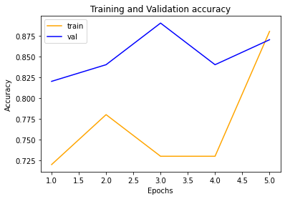

Fig 4.3. Accuracy Graph for MobileNet

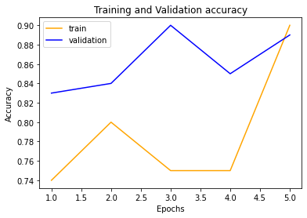

Fig 4.4. Accuracy Graph for InceptionNetV3 Model

1. **Conclusion**

This project is a deep learning project for classification of cervical cancer. This project will help pathologists to interpret images of cells from pap smear tests. The deep learning model was built using google colab and keras as well as tensorflow library. The project achieved the development of a deep learning model to classify normal and abnormal cases. This model is recommended for use in classifying cervical cancer. This project can be tested on more CNN model architectures in the future for better accuracy. It can be implemented with the best GPU to speed up the training of the model. The classes can be divided into three classes; normal cells, low-grade(ASC-US and LSIL) and high-grade (ASC-H, HSIL, SCC). The classes can also be further divided into six; normal cells that is negative for intraepithelial lesion or malignancy (NILM)); atypical squamous cells of undetermined significance (ASC-US); low-grade squamous intraepithelial lesion (LSIL); atypical squamous cells, cannot exclude high-grade lesion (ASC-H); high-grade squamous intraepithelial lesion (HSIL); squamous cell carcinoma (SCC).

The data was obtained from CRIC searchable database. With the use of transfer learning, MobileNet and InceptionNet architectures were used to retrain the models with an accuracy score for 88% for MobileNet and 90% for InceptionNetV3.

**References**

.

1. Adamson, A., 2021. *Opinion: AI Could Aid Cancer Diagnosis, but Caution Is Needed*. [online] The Scientist Magazine®. Available at: <https://www.the-scientist.com/critic-at-large/opinion-ai-could-aid-cancer-diagnosis-but-caution-is-needed-68584> [Accessed 12 January 2022].

2. Akst, J., 2018. *AI Networks Generate Super-Resolution from Basic Microscopy*. [online] The Scientist Magazine®. Available at: <https://www.the-scientist.com/news-opinion/ai-networks-generate-super-resolution-from-basic-microscopy-65219> [Accessed 12 January 2022].

3. Akst, J., 2019. *A Primer: Artificial Intelligence Versus Neural Networks*. [online] The Scientist Magazine®. Available at: <https://www.the-scientist.com/magazine-issue/artificial-intelligence-versus-neural-networks-65802> [Accessed 12 January 2022].

4. Cancer.Net. 2020. *Cervical Cancer - Symptoms and Signs*. [online] Available at: <https://www.cancer.net/cancer-types/cervical-cancer/symptoms-and-signs> [Accessed 12 January 2022].

*5. CDC*. [online] Available at:<<https://www.ncbi.nlm.nih.gov/pmc/articles/PMC6098589/>>[Accessed 12 January 2022].

6. Cdc.gov. n.d. *Basic Information About Cervical Cancer | CDC*. [online] Available at: <https://www.cdc.gov/cancer/cervical/basic_info/index.htm> [Accessed 12 January 2022].

7. Chandra, A., 2018. *McCulloch-Pitts Neuron — Mankind’s First Mathematical Model Of A Biological Neuron*. [online] Medium. Available at: https://towardsdatascience.com/mcculloch-pitts-model-5fdf65ac5dd1> [Accessed 12 January 2022].

8. Chandra, A., 2018. *McCulloch-Pitts Neuron — Mankind’s First Mathematical Model Of A Biological Neuron,* image, viewed 12 January, 2022, *<* [https://towardsdatascience.com/mcculloch-pitts-model-5fdf65ac5dd1>](https://towardsdatascience.com/mcculloch-pitts-model-5fdf65ac5dd1%3E)

9. Dance, A., 2019. *AI Uses Images and Omics to Decode Cancer*. [online] The Scientist Magazine®. Available at: <https://www.the-scientist.com/features/ai-uses-images-and-omics-to-decode-cancer-65732> [Accessed 12 January 2022].

10. Dean, J. and Ng, A., 2012. *Using large-scale brain simulations for machine learning and A.I.*. [online] Google. Available at: <https://blog.google/technology/ai/using-large-scale-brain-simulations-for/> [Accessed 12 January 2022].

11. Eurocytology.eu. 2022. *Atypical squamous cells of undetermined significance (ASC-US) | Eurocytology*. [online] Available at: <https://www.eurocytology.eu/en/course/1290> [Accessed 3 February 2022].

12. Howard., J 2017, *Cervical cancer death rates are much higher than thought, study says, i*mage, viewed 12 January 2022, < https://edition.cnn.com/2017/01/23/health/cervical-cancer-death-study/index.html >

13. King, A., 2020. *Algorithm Spots COVID-19 Cases from Eye Images: Preprint*. [online] The Scientist Magazine®. Available at: <https://www.the-scientist.com/news-opinion/algorithm-spots-covid-19-cases-from-eye-images-preprint-67950> [Accessed 12 January 2022].

14. Kwon, D., 2019. *Deep Learning Algorithms Identify Structures in Living Cells*. [online] The Scientist Magazine®. Available at: <https://www.the-scientist.com/notebook/deep-learning-algorithms-identify-structures-in-living-cells-65778> [Accessed 12 January 2022].

15. Makowski, E., 2019. *Image of the Day: Melanoma Neural Network*. [online] The Scientist Magazine®. Available at: <https://www.the-scientist.com/image-of-the-day/image-of-the-day--melanoma-neural-network-66825> [Accessed 12 January 2022].

16. Marr, B., 2021. *A Short History Of Deep Learning -- Everyone Should Read | Bernard Marr*. [online] Bernard Marr. Available at: <https://bernardmarr.com/a-short-history-of-deep-learning-everyone-should-read/> [Accessed 12 January 2022].

17. National Cancer Institute. n.d. *What Is Cancer?*. [online] Available at: <https://www.cancer.gov/about-cancer/understanding/what-is-cancer> [Accessed 12 January 2022].

*18. Number of fully connected layers in standard CNN*, image, viewed 12 January, 2022, <[https://datascience.stackexchange.com/questions/31175/number-of-fully-connected-layers-in-standard-cnns>](https://datascience.stackexchange.com/questions/31175/number-of-fully-connected-layers-in-standard-cnns%3e)

19. Offord, C., 2019. *AI App Identifies Rare Genetic Disorders from Photos of Patients’ Faces*. [online] The Scientist Magazine®. Available at: <https://www.the-scientist.com/news-opinion/ai-app-identifies-rare-genetic-disorders-from-photos-of-patient-faces-65295> [Accessed 12 January 2022].

20. Renfrow, J., 2019. *1 in 3 misdiagnoses results in serious injury or death: study*. [online] FierceHealthcare. Available at: <https://www.fiercehealthcare.com/hospitals-health-systems/jhu-1-3-misdiagnoses-results-serious-injury-or-death> [Accessed 12 January 2022].

21. Roswell Park Comprehensive Cancer Center. n.d. *Cervical Cancer Survival Rate*. [online] Available at: <https://www.roswellpark.org/cancer/cervical/survival-rate> [Accessed 12 January 2022].

22. Sharma, N., 2020. *What is GoogleNet architecture?,* image, viewed 12 January, 2022, <<https://www.quora.com/What-is-GoogLeNet-s-architecture>>

23. SnapStack. n.d. *Data Augmentation - Advantages, Challenges, and Instances - SnapStack*. [online] Available at: <https://snapstack.cz/data-augmentation-advantages-challenges-and-instances/> [Accessed 12 January 2022].

24. Williams, R., 2019. *Infographic: Human-Style Image Analysis Without the Human*. [online] The Scientist Magazine®. Available at: <https://www.the-scientist.com/infographics/infographic--human-style-image-analysis-without-the-human-65804> [Accessed 12 January 2022].

25. Williams, S., 2019. *AI Accurately Detects Lung Cancer in Scans*. [online] The Scientist Magazine®. Available at: <https://www.the-scientist.com/news-opinion/ai-accurately-detects-lung-cancer-in-scans-65914> [Accessed 12 January 2022].